
Contact

Send you Cv’s to hr@mazco.com.sa

Or

Post Box: 2486, Dammam 31451,
KINGDOM OF SAUDI ARABIA.
Tell: +966 3 8260080 EXT: 31
Fax : +966 3 8266618
Website::www.mazco.com.sa

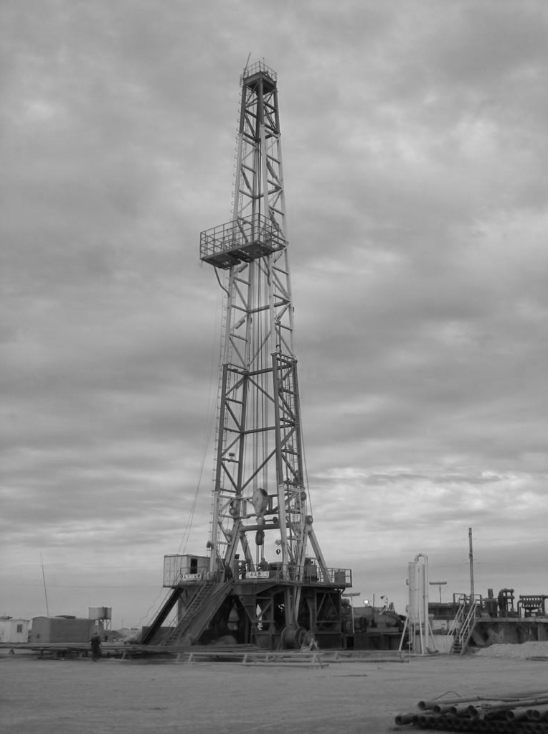
Job Description:

Derrick Man shall:

    - Load and unload boats and trucks safely.
    - Working on rig floor: demonstrate the ability to successfully handle tubulars utilizing the proper equipment and technique, namely air, top drive, rig tongs, chain tongs pipe spinners, iron rough neck, collar clamp, etc.
    - Adequately apply safety precautions while testing, logging, etc.
    - Perform routine maintenance on rig floor and handling tubular goods: understand and demonstrate the ability to conduct minor repair of rig tongs, chain tongs, pipe slips, collar lamp and pipe elevator.
    - Inspect and maintain tubular box and pin connection, dies, nuts, bolts, on drilling equipment for wear and/or damage.
    - Perform pump house operation, assist in maintaining/repairing mud pumps and participate in mixing/maintaining drilling fluids.
    - Perform under general supervision, minor electrical work, heavy carpentry, metal cutting, pipe filling, machine maintenance and others.

Qualification:
  - Have a minimum of four years training on the job and experience as a rig man, including both floor and derrick work.
  - Must able to understand work directions in English.
  - Familiar with the nomenclature of rotary drilling equipment.
  - Must possess physical stamina.
  - Have a good sense of balance and coordination to be able to work safely at heights in excess of 100 feet.
  - Willing to perform hard and hazardous work under extreme weather conditions involved in drilling wells and living at isolated well sites.

Derrick Man

